New Sonning HC Training Kit Available

We are pleased to announce a new range of training kit options, available for all players, is being provide by our kit partner Hawkin Sport.

What’s new…?
- Bespoke Tracksuit Bottoms especially for us.
- Soft-shell Gilet
- Soft-shell Jacket
- Bespoke Sonning HC home Socks

Limited time SPECIAL OFFER!
- Buy the new tracksuit bottoms and training top combo (either gilet or jacket) and you will receive the socks for FREE!
- You do not need to order the socks separately. Hawkin Sport will manually check your order, recognise the combo, and provide them for free.
- Please put your required sock size in the “notes” section of your order.
- This offer is valid for orders placed by 30th September.

To order…
...go to the Club Shop...
…or visit: Hawkin Sport & Son, 37/39 The Parade, Bourne End, SL8 5SB

More information:
- All items can be purchased individually.
- As the Trackuit Bottoms are bespoke they may be subject to a 4-6 week leadtime depending on stock.
- Playing shirts and other kit is still available to purchase as per normal.
- Gilet & Tracksuit Bottom bundle = £65. Jacket & Tracksuit Bottom bundle = £75. Gilet & Jacket & Tracksuit Bottom bundle = £110. All of which get the socks for free!
Bespoke Tracksuit bottoms:
  - These are made specifically for the club. They are navy with a royal blue panel running down the size with yellow piping.
  - They come with a knee length zip and pockets
  - Cost - £30, which includes your initials.
  - As these are bespoke – a 4 week lead time may occur if the shop stock doesn’t have your size.
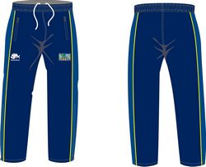
Soft-shell Gilet and Jacket:
  - This is a performance membrane mid layer top with fleece lining and water sealed pockets
  - Both items are the same (just one without sleeves)
  - Great for training in (gilet etc) as well as wearing pre and post match
  - On the back will be Sonning HC (in the club font)
  - On the front will be the club crest (embroider) and your initials
  - Feel free to purchase one or both!
  - These are stock items so will have quick turn around
  - Cost – Gilet £35, Jacket £45
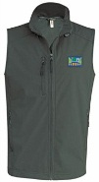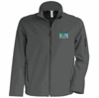
Bespoke Sonning HC home Socks:
  - A navy sock with SHC woven into the calf in yellow.
  - These are really good quality and have a cushioned foot area.
  - These will be stock items once they are in !
  - Cost £8

